Q8W Work Area Setting APP
User Guide
1、Download installation package
1.1. Get the application installation package through the ugee official website;
1.2. Download the “size setting. apk” and save it to your phone/tablet;
1.3. After installing the application, you will find a small ugee icon (application name: Size setting) on your phone/tablet desktop.
2. Device Connection
2.1 Bluetooth Connection
2.1.1. Open the application and pop up to obtain location information. Please select Allow (option 1 or 2);
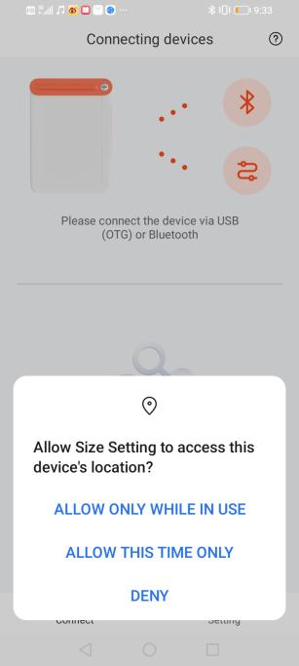
2.1.2. After power on the Q8W, quickly press the power button 3 times in a row , and the green light will flash quickly to enter the connection pairing interface), click on the connect button of the application , pop up the box, and select Pair. (Some phones may have two pop ups, please ignore if there are no issues with usage);
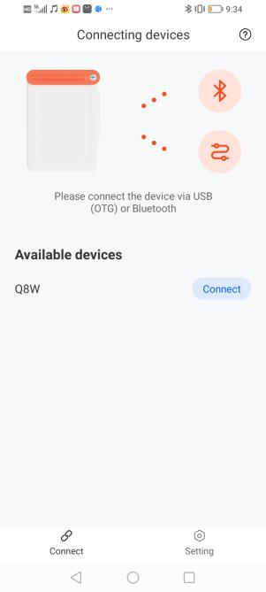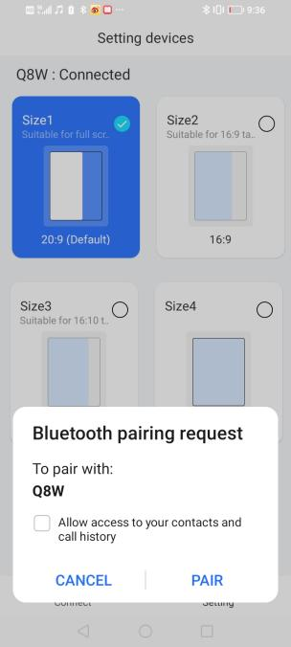
2.1.3.Enter the setting interface and set the ratio you want to set.
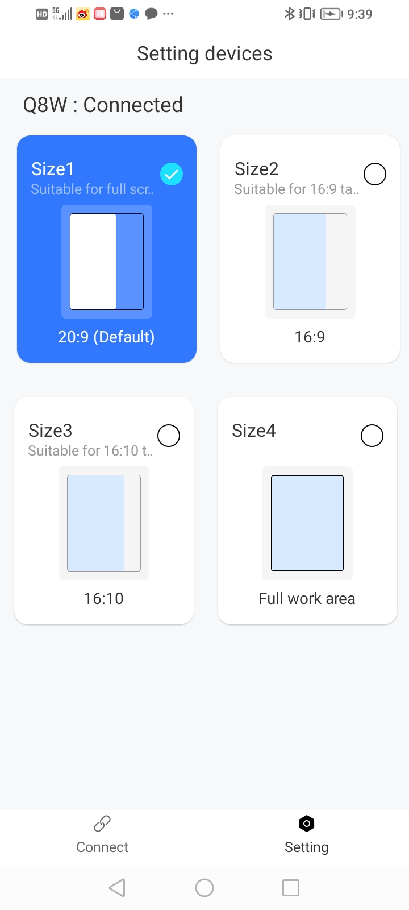

2.2 Wired connection method
2.2.1. Confirm that the OTG switch on the phone is turned on;
2.2.2. Connect the phone to the Q8W through a USB cable;
2.2.3. Open the “Size setting”application and select OK in the pop-up window;
2.2.4. After successful connection, it will automatically jump to the proportion switching page.
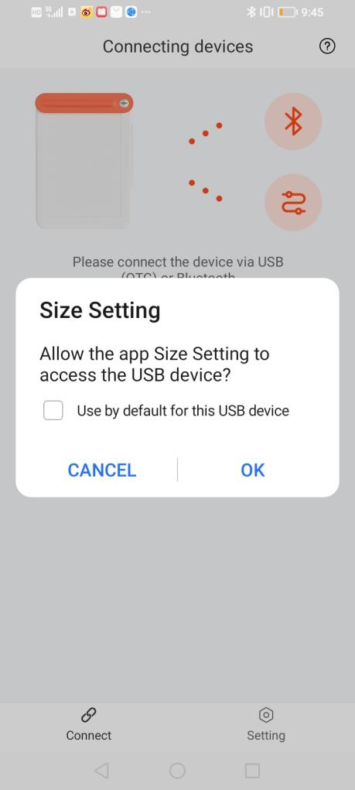

3、 FAQ:
Some mobile phones may happen:
After connecting the Q8W to the Bluetooth of the phone
first, you may not find it in the "Size setting" app.
Solution: First disconnect the Bluetooth from the system settings, then enter the size setting app to connect - set the ratio, and then open the system settings to connect to the Q8W again.

