How to fix the "InitLib failed, Use will be terminated soon, please contact the manufacturer!" issue on Windows computer?

Description:
When using the tablet on a Windows computer, a pop-up window displays the error: "InitLib failed, Use will be terminated soon, please contact the manufacturer!"

Troubleshooting Steps:

Step 1: Check and uninstall conflicting software
Please check whether there is an app called G-SPY or GSPY installed on your computer. You can find it in "Device Manager" or in your "Application List".

If you find it, please uninstall it, restart your computer, and then check if you can open the driver normally.
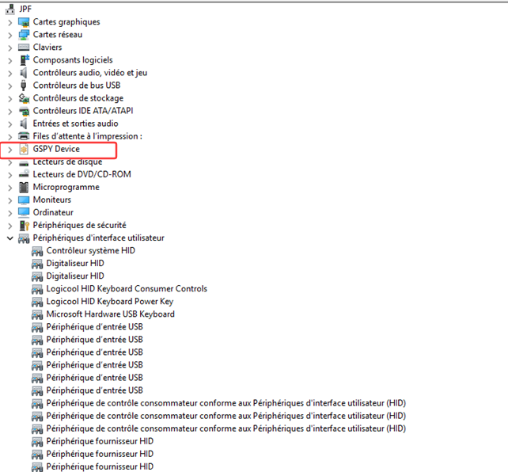

Step 2: Install an earlier version of the driver (If G-SPY is not found)

If you cannot find G-SPY or GSPY on your PC, please try installing an earlier version of the driver:

https://drive.google.com/file/d/1zKLj0NO0xRrRI_9EYnRTmQma4PkiUigQ/view?usp=sharing

After downloading, please run the program as 'Administrator' when installing the driver.

Once installed, please double-click on "UgeeTablet" to open the driver.

If the issue persists, please feel free to contact our technical support team for further assistance: service@ugee.com

