What to do if the work area in the driver displays abnormally?
- If the work area was configured incorrectly, resulting in the situation shown below:
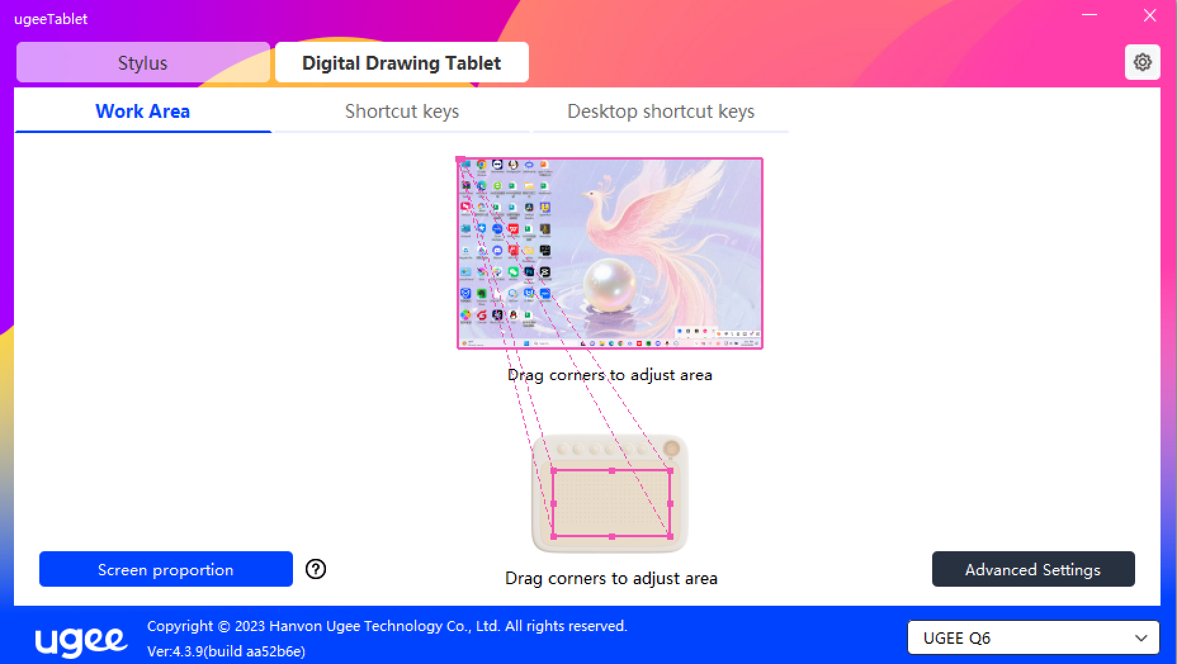
2. Simply just click on the “Default” key in the settings.
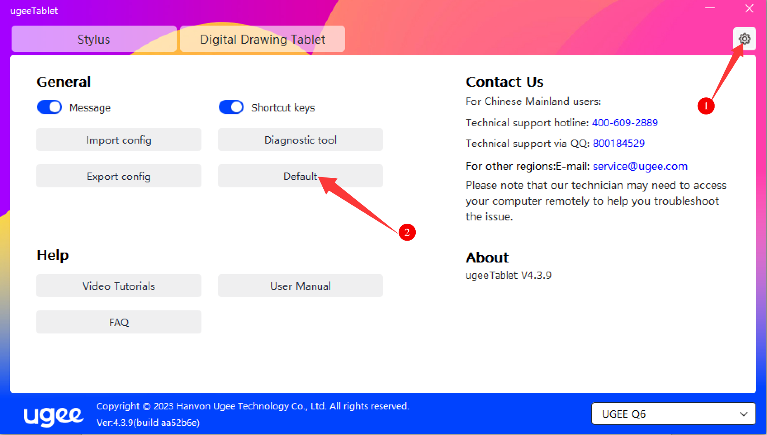
3. If the work area remains disordered even after restoring the defaults, please check if you are using a USB Hub or splitter. We recommend connecting the tablet directly to a USB port on your computer and trying again.

