How to Uninstall the Ugee Driver on Windows
1.Locate the Ugee driver icon on your desktop, right-click it, and select Open file location.
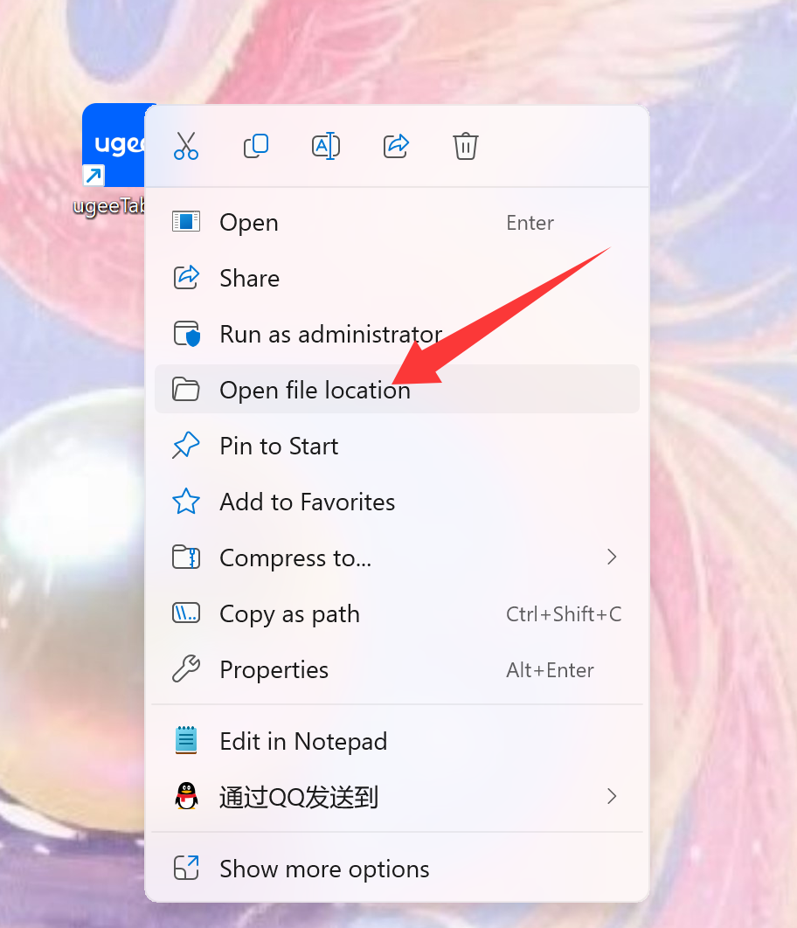
2. Find the uninstallation file named unins000.exe and double-click it.
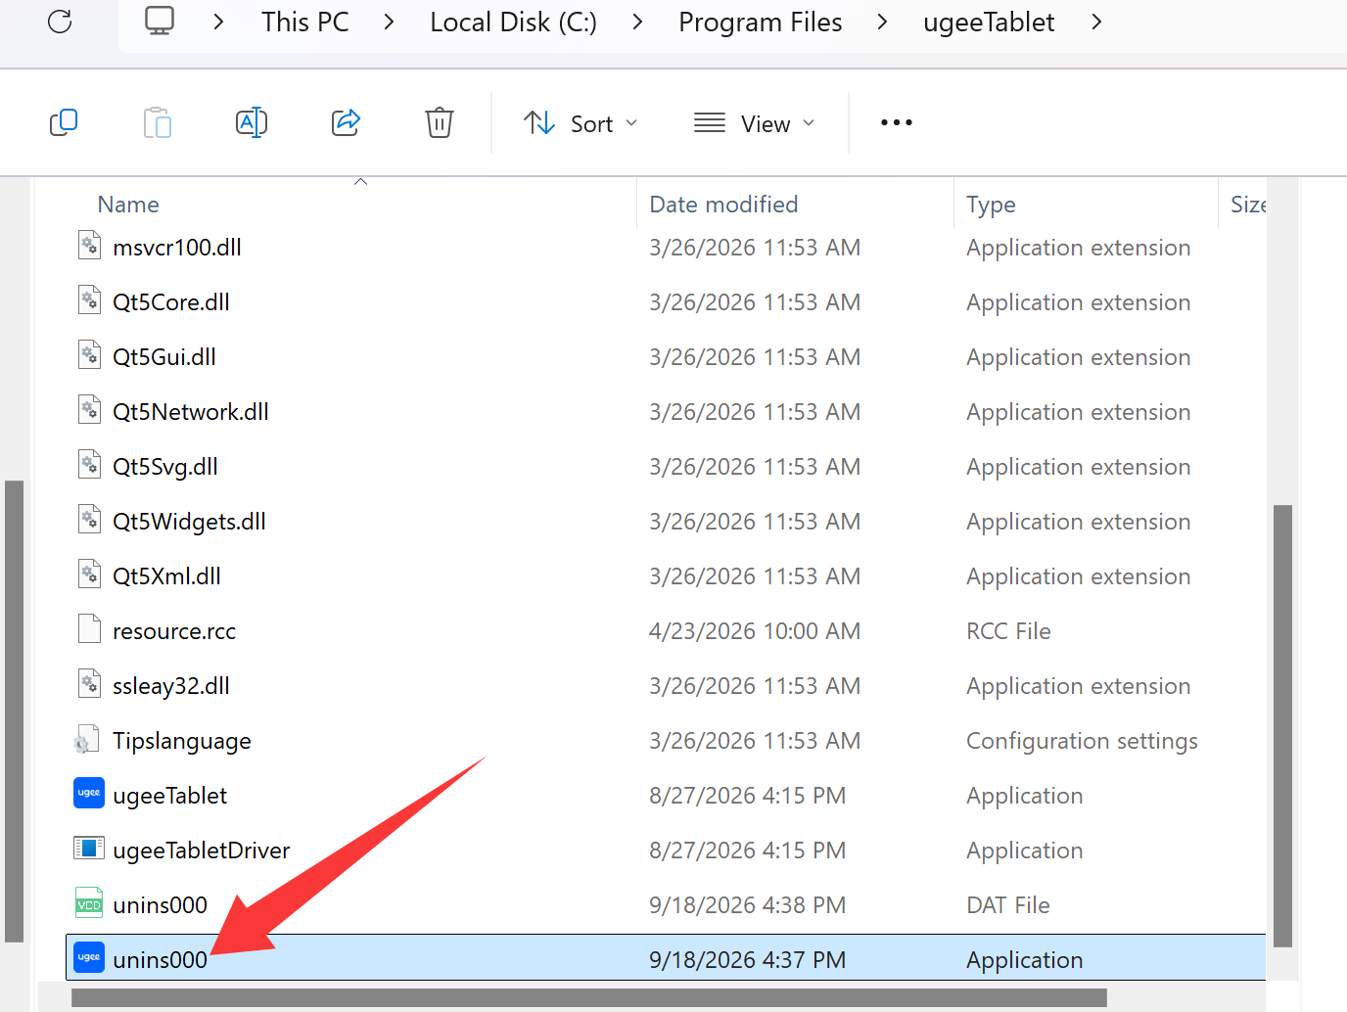
3. When the confirmation prompt appears, click Yes to proceed with the uninstallation.
