How to Scribble in WPS Word
- Open WPS Word and navigate to the Review tab.
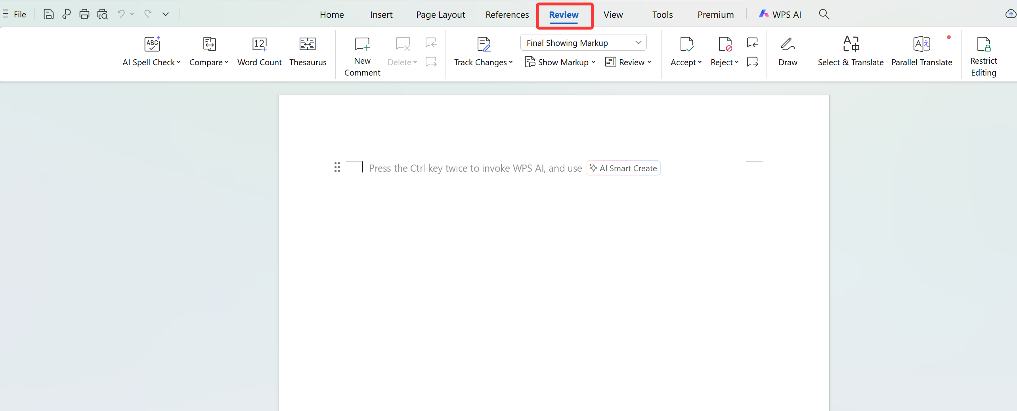
2. Activate the Draw feature and select a pen to start writing freely on the document.
