How to Scribble in WPS PPT

1.Open your WPS PPT file, click on the Review tab, and select the Pen tool to start writing freely. If your WPS has a Draw tab, you can click it directly and select a pen to write with.

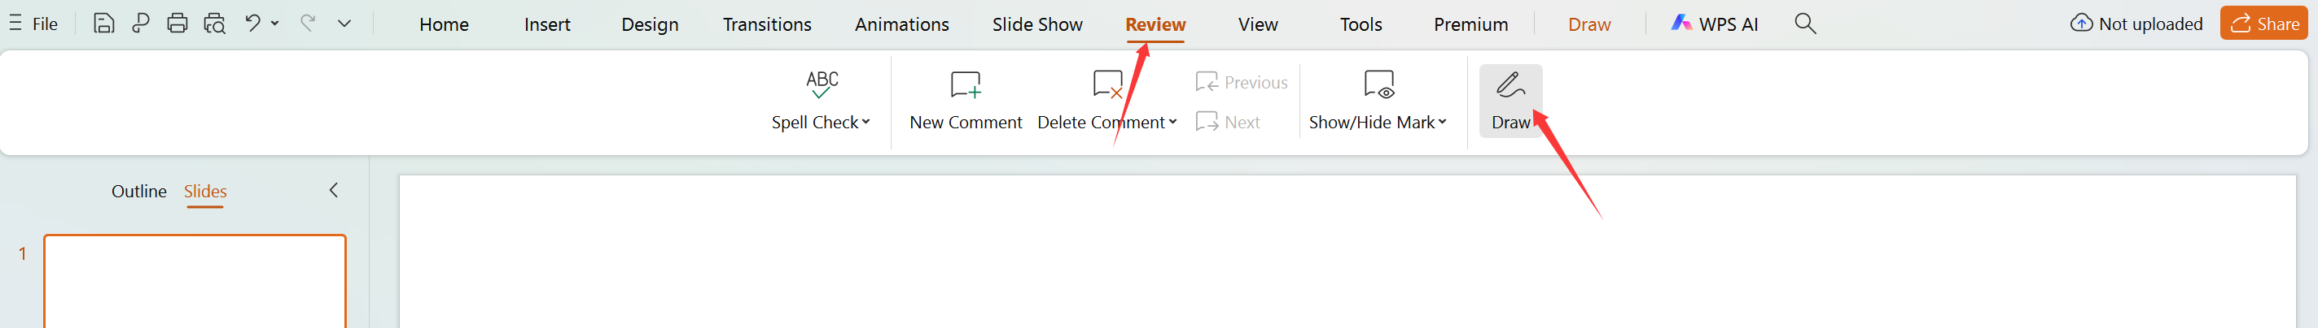

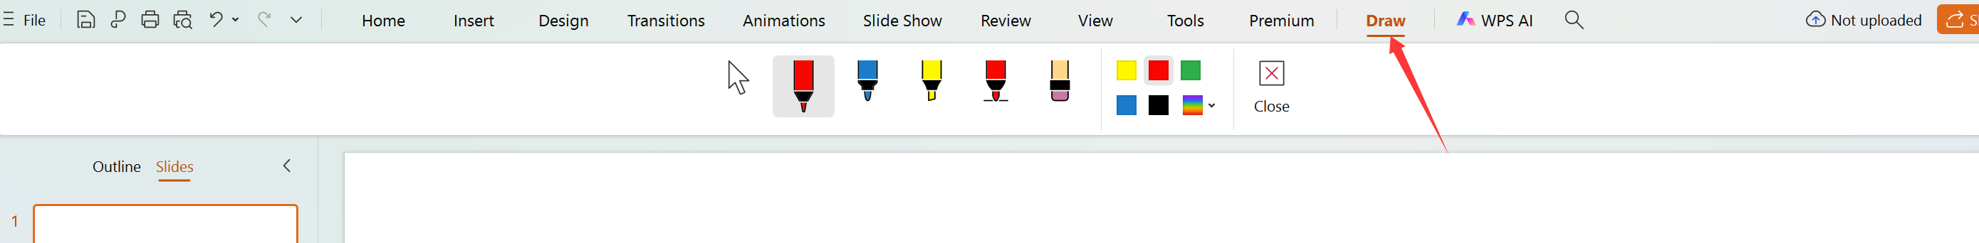
- In Slide Show mode, locate and select the Pen function in the bottom-left corner to start writing freely.


