How to Scribble in WPS PDF

- Open your WPS PDF file, go to the Comment tab, and select the Draw feature.
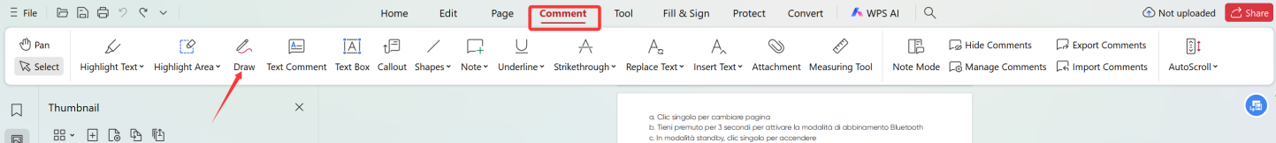
- Move your pen across the tablet to start writing or drawing freely.
