How to Install Ugee Driver on a Windows Computer
1. Open the webpage and enter: http://www.ugee.com, click on the "Driver Download" section.
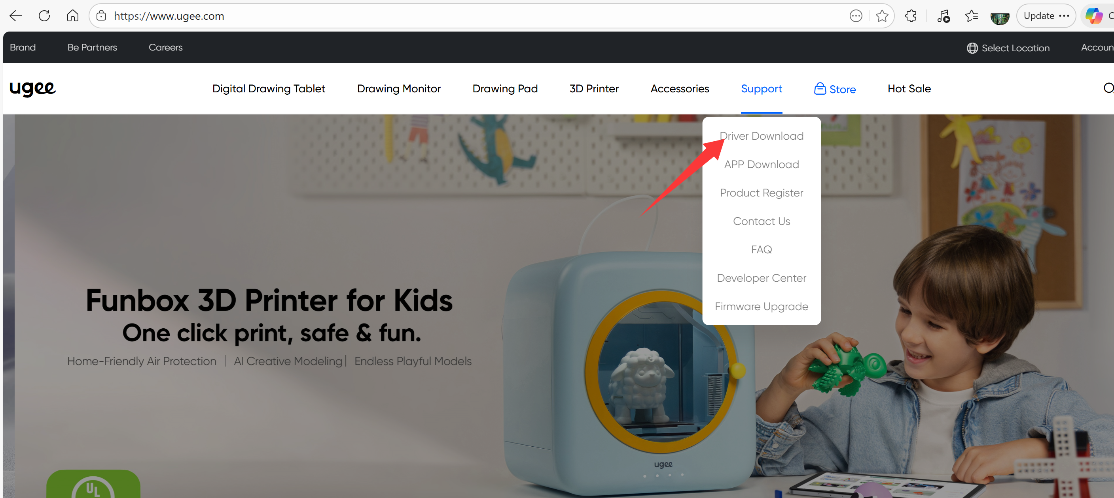
2. Click on the tablet model you own. For example: M908
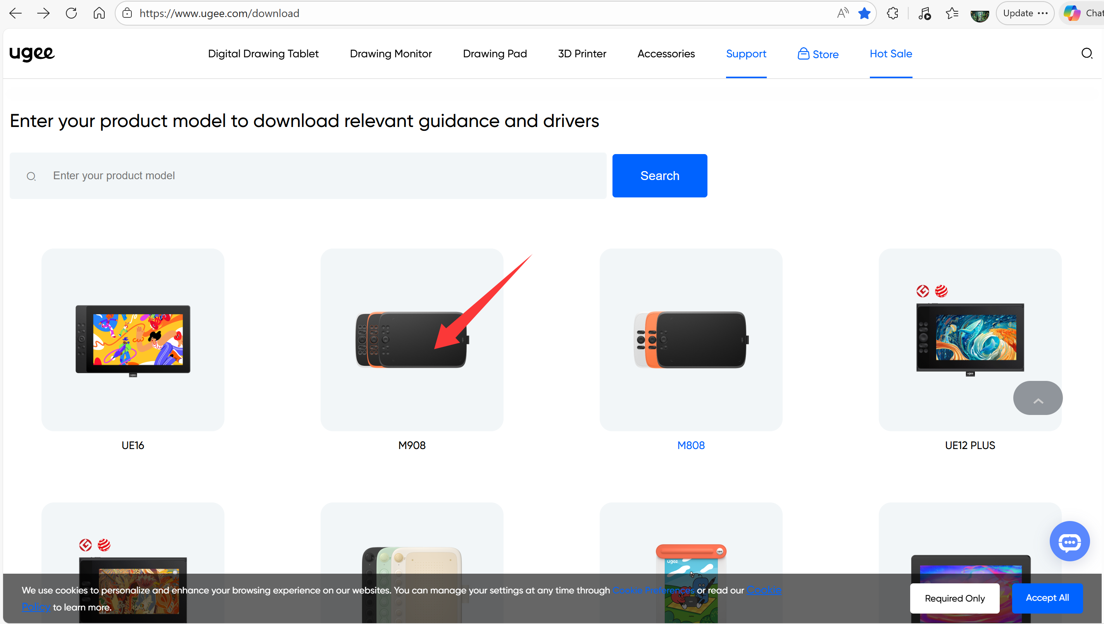
3. Drivers are available for both Windows, Mac, and Linux systems; please select the Windows version.
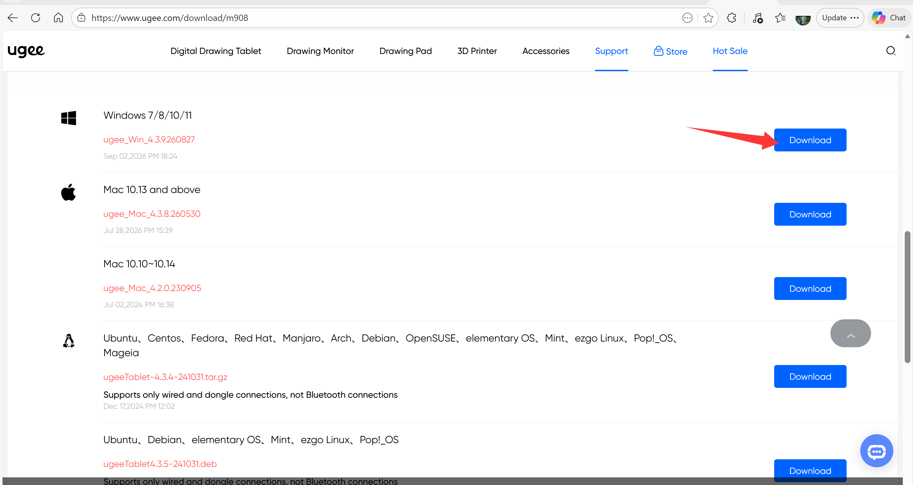
4. After downloading, right-click to extract the folder (Windows 11 can extract ZIP files natively; if your system cannot, you need to install an extraction tool first like 7-zip). When installing the driver, first exit the antivirus software on your computer and then install it with Administrator privileges.
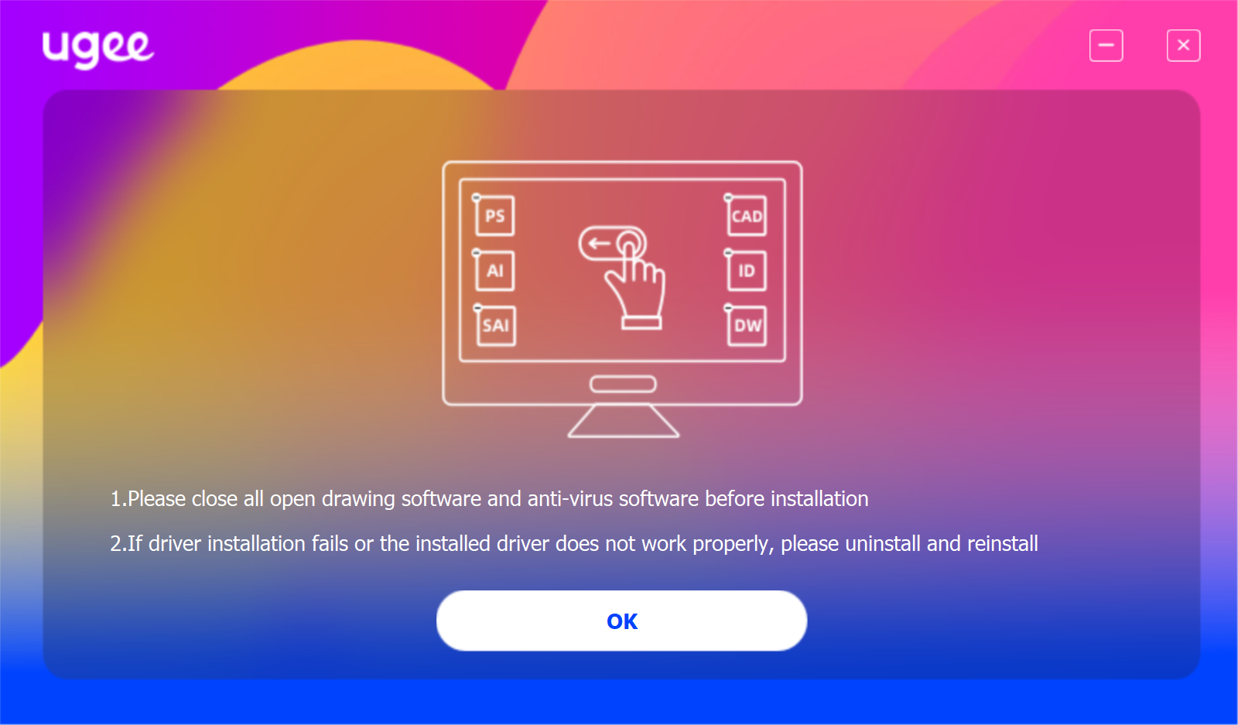

5. After installation, a prompt will ask you to “Restart later” or “Restart now”.
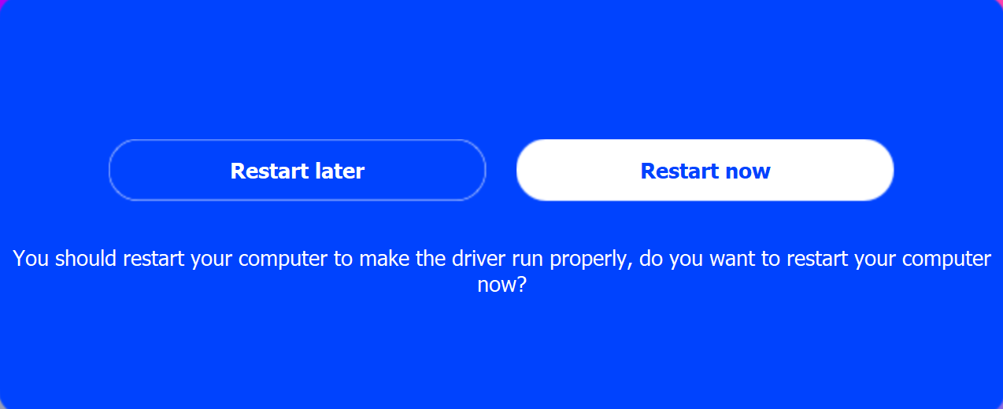
6. After restarting, if the following icon appears on the desktop, it indicates the driver installation is complete.


