How to Fix Scroll Wheel Zoom Issues
1. Open the Ugee Driver and locate the 「Roller settings」 option.

- Select 「Zoom」 from the function list, and then select “Customize”.
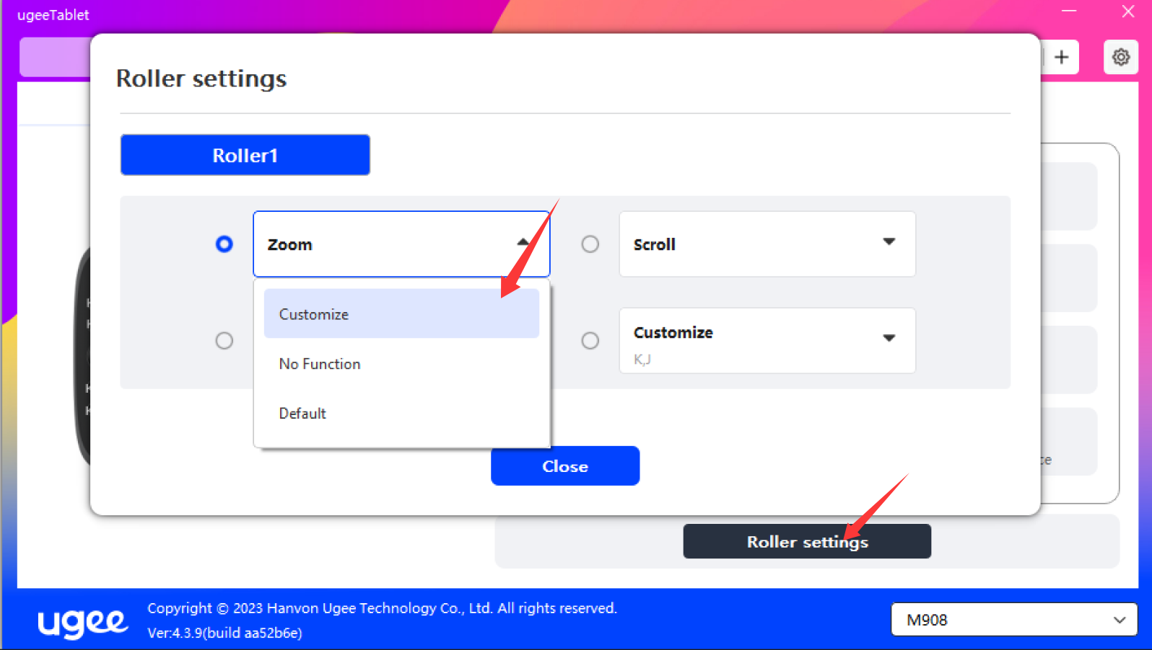
3. Important: Switch your input method to English. Use your keyboard to input Ctrl + - (Zoom Out) and Ctrl + = (Zoom In).

Note: You must press Ctrl and the - / + keys simultaneously.
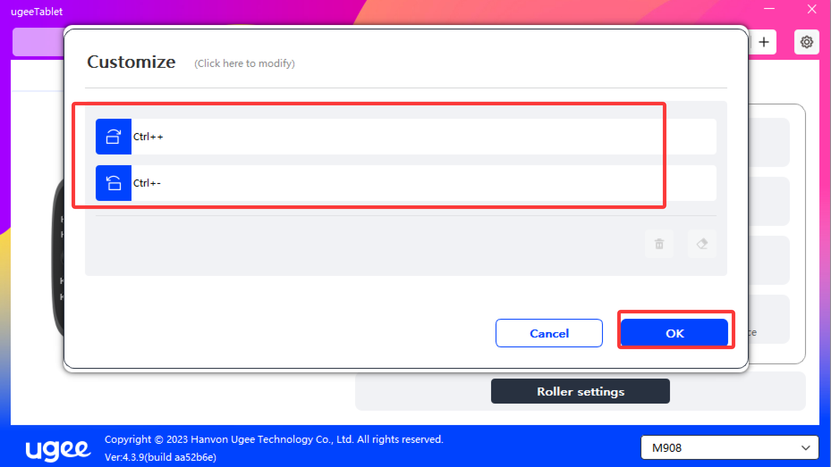
4. After saving the settings, restart your drawing software to use the canvas zoom function normally.

