How to Disable "Press and Hold" Right-Click in Windows 11
Customers who use drawing tablets often run into a common issue: a circle appears around the mouse cursor while drawing, followed by a right-click menu popping up. This really ruins the drawing experience. This is caused by the system's "Press and Hold" feature, which can be easily turned off.

Here is the solution:
- Please locate the “Pen and Touch” settings via following path and open it:
Control Panel -> Hardware and Sound -> Pen and Touch
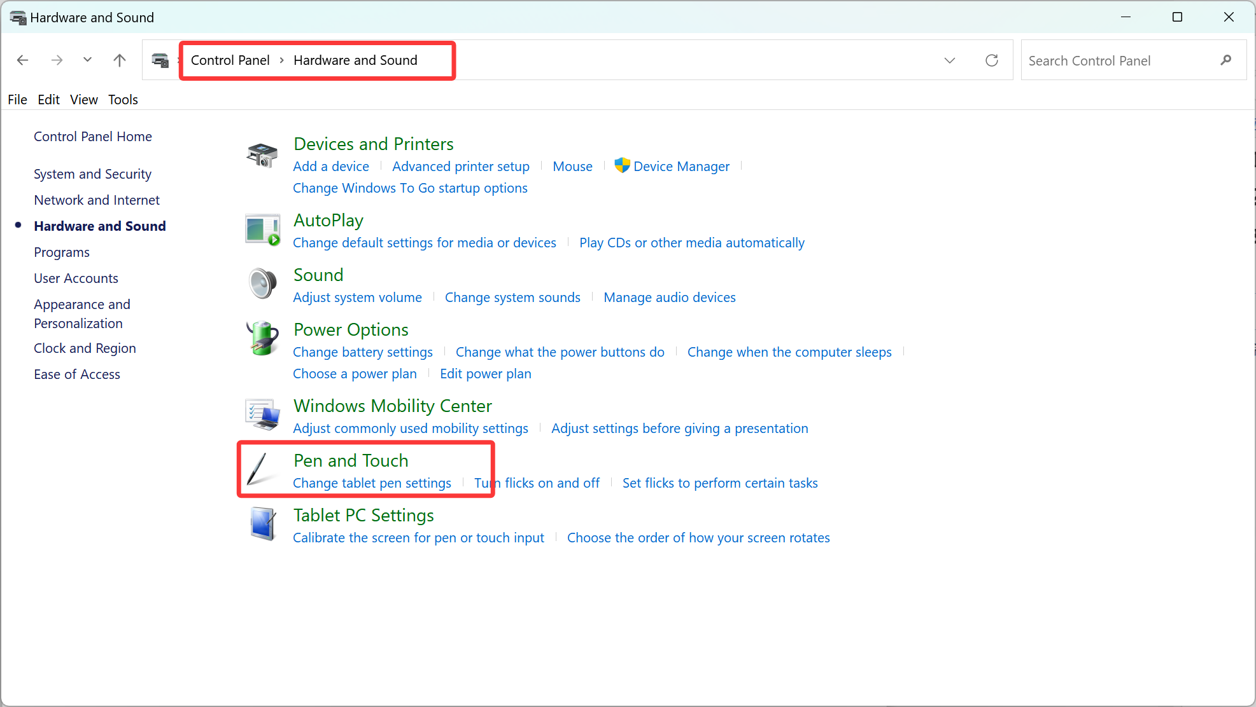
- Click on Pen Options -> Press and hold -> Settings.
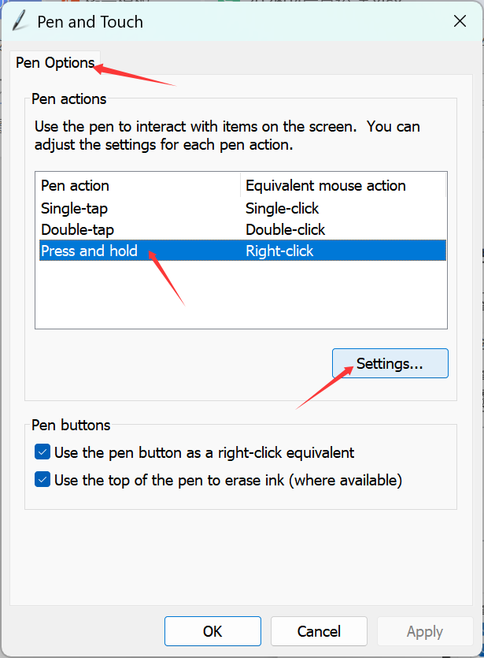
3. Uncheck the box for "Enable Press and Hold for right-clicking", click on “OK” button, and the problem is solved.
