How to Configure Canvas Rotation in SAI2
1. Open SAI2 and navigate to the Shortcut Settings.
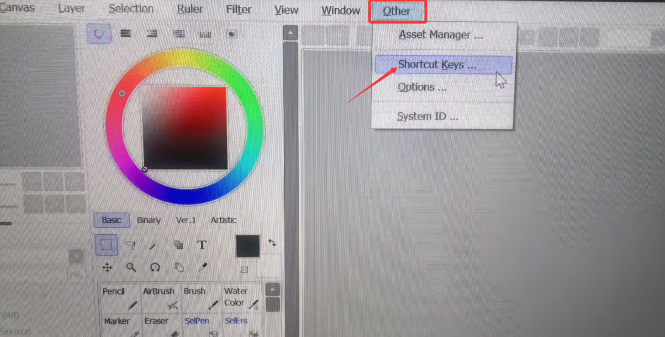

2.In the left column, navigate to two empty shortcut slots. In the right column, click on View and locate Rotate.
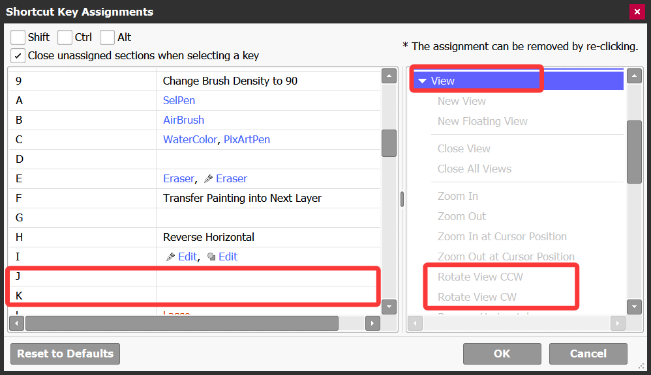

3. Set J to counter-clockwise rotation and K to clockwise rotation, then press OK to save.
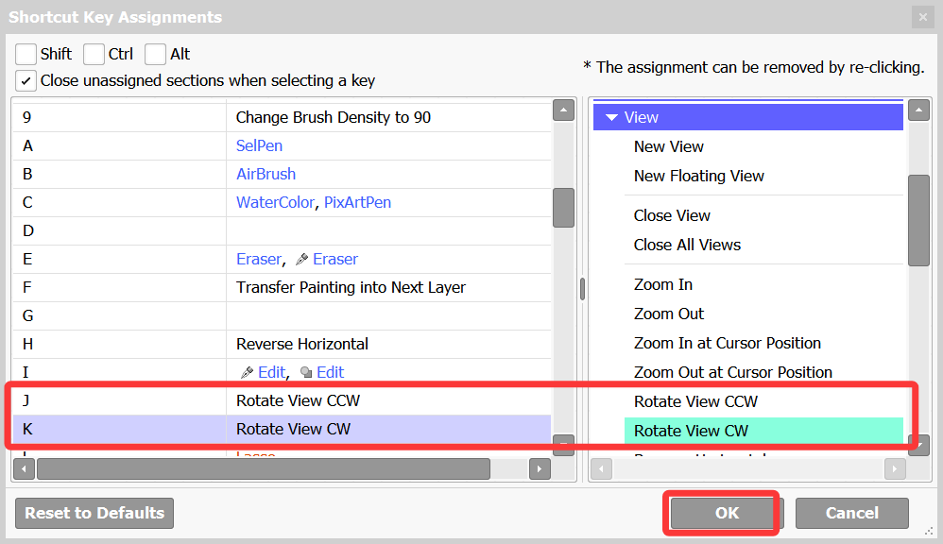
4. Open the driver, locate the Roller settings, click on the rotation function, and select Customize.
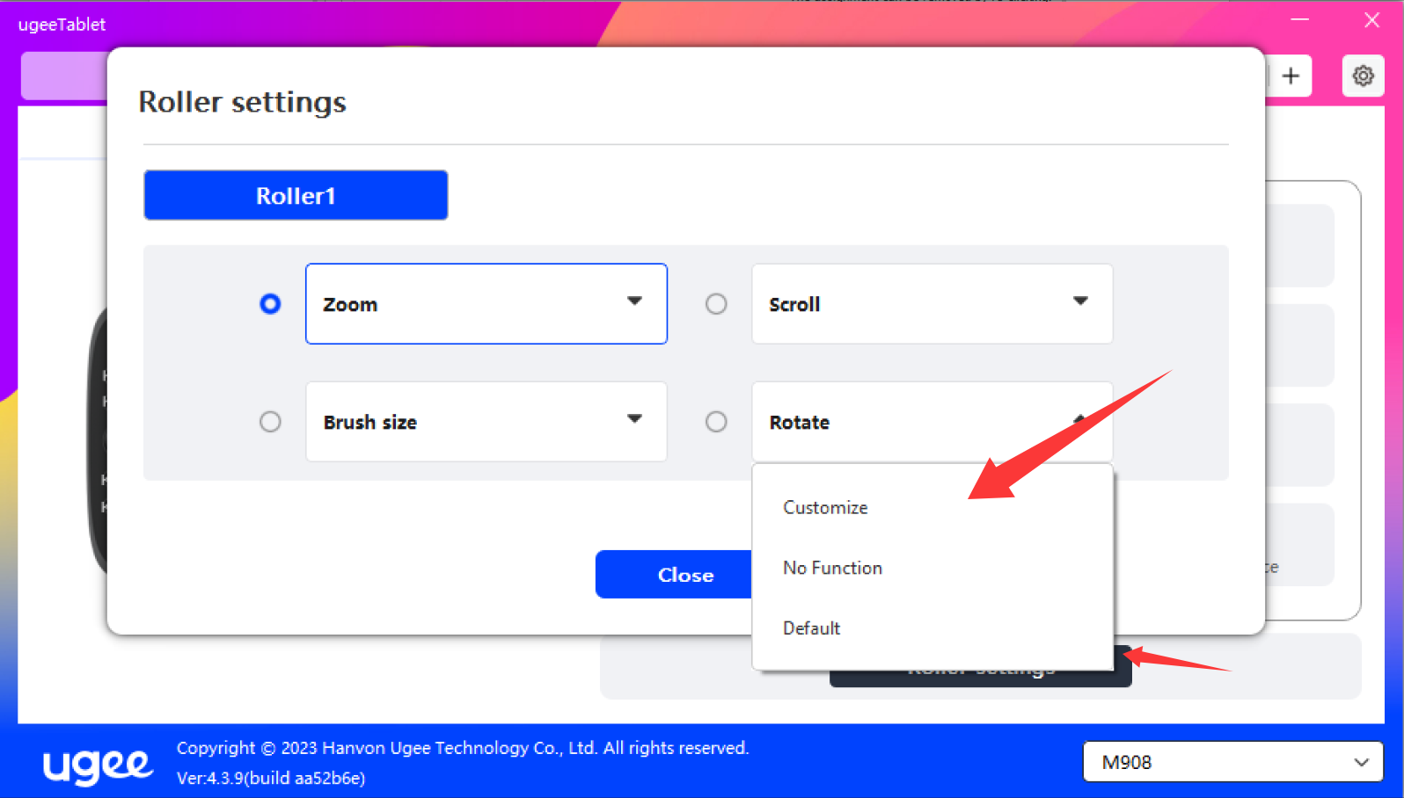
5. Configure the settings to match J and K in SAI2, and press OK to save.
