Fix for Windows 11 Pen Input Box Not Popping Up

- Search for Windows Ink in the search bar — select Pen & Windows Ink settings.
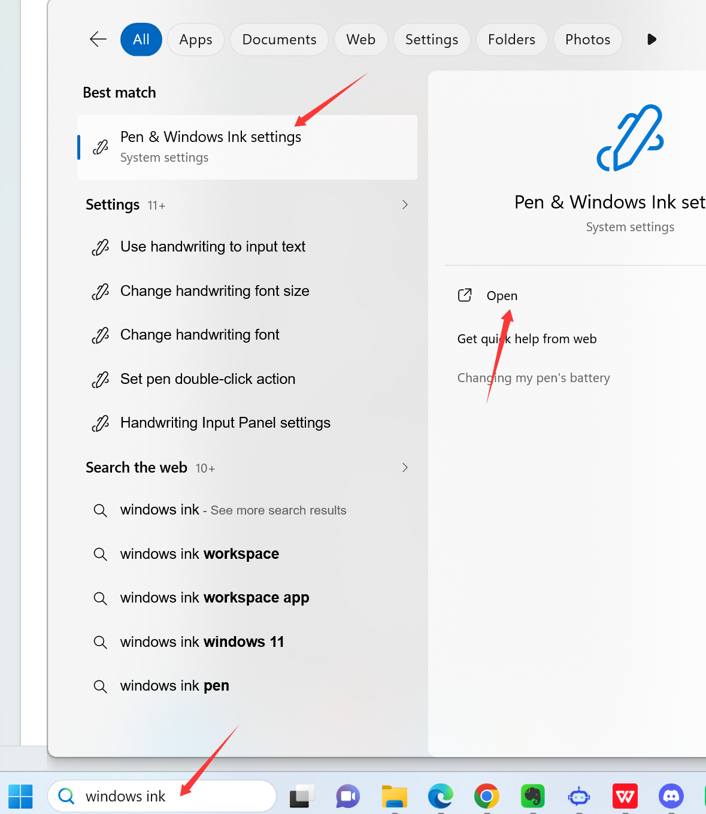
Under Handwriting panel settings — select When a keyboard is not attached, and ensure the driver is set to use Windows Ink.
