Do I need to install two or more tablet drivers for multiple devices
If you have multiple ugee devices, there is no need to install two or more tablet drivers. Currently, the drivers can work with two or more devices at the same time. When you want to change the settings for the tablet, click on the device name, then swith to other devices. Below is the list of devices that can work on the same driver versionUGEEWin_4.3.9.
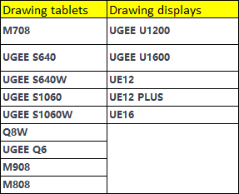
For further questions, please contact online support chat on official website or email service@ugee.com.

