How to Fix Lag and Stuttering Issues in WPS PPT

- Open the UGEE driver > Stylus> Pen settings, uncheck Windows Ink.
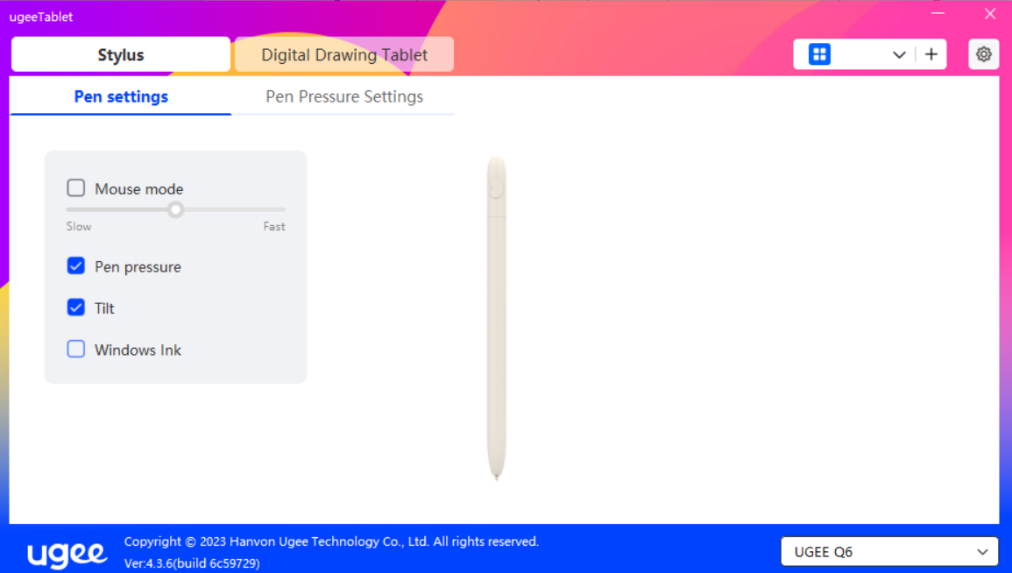

- If the problem persists even after disabling Windows Ink, try the second method:
Open PPT> File> Options> View> uncheck Enable hardware graphics acceleration, restart WPS.
