How to set up zooming in Photoshop using the mouse wheel?
- In Photoshop, select Edit > Preferences > Tools from the top menu bar.
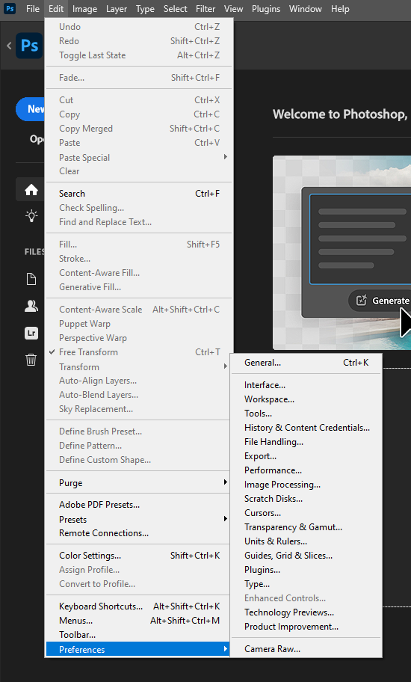

- Check “Zoom with Scroll Wheel”
