How to Fix Cursor Jitter When Using a Drawing Tablet with Photoshop's Liquify Tool

The Liquify tool in Photoshop consumes a significant amount of system hardware resources. Sometimes, when the hardware isn't powerful enough, cursor jitter may occur.

System Environment: Windows 11

Solution:

If your computer has a graphics card, this solution applies only to NVIDIA graphics cards. Right‑click on an empty area of the desktop → select Show more options → then choose NVIDIA Control Panel.
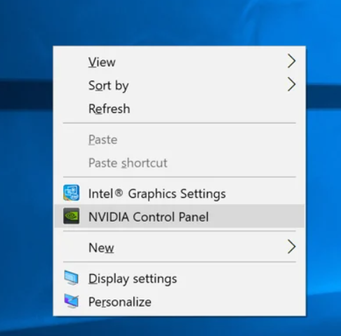

Go to Manage 3D Settings → Program Settings → select Photoshop from the list.
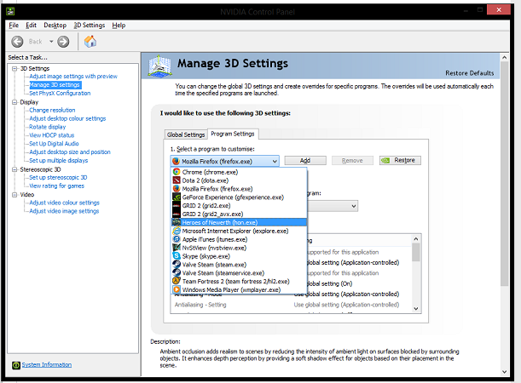

Turn off (disable) Vertical Sync.
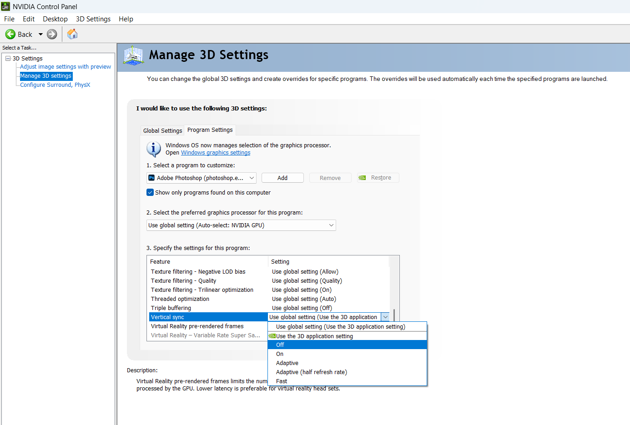

Restart your computer and test.

