How to disable the water ripple effect when using UGEE tablet on Windows 11 computer?

- Click the Start menu in the lower-left corner of the screen.
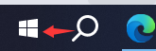

- Select Settings.
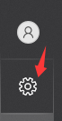

- Go to Pen & Windows Ink.
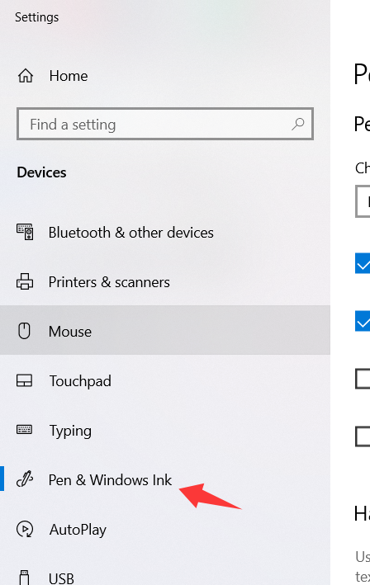

- Under Pen settings, uncheck "Show visual effects" to apply the setting successfully.

