How to write on a PDF using the Edge browser
- Please download and install the XPPen tablet driver from the website https://www.xp-pen.com/download
- Ensure the graphics tablet or tablet display is connected to your computer, and the pen can control the cursor.
- Right-click on your PDF file, hover the mouse to ‘open with’, then select ‘Mircosoft Edge’.
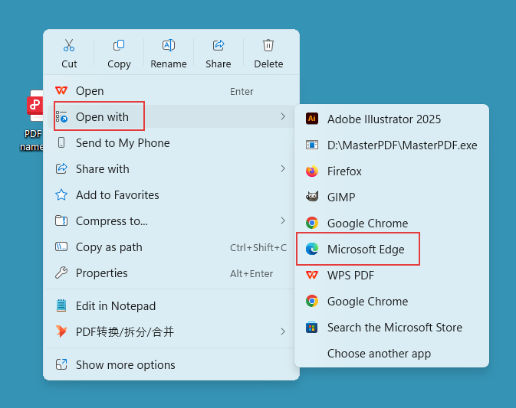
- Select the highlight tool or draw tool on the tool bar to edit your PDF file.
