How to set up zooming in Photoshop using the mouse wheel?
- Move the mouse to the Photoshop menu bar, go to Edit> Preferences> Tools.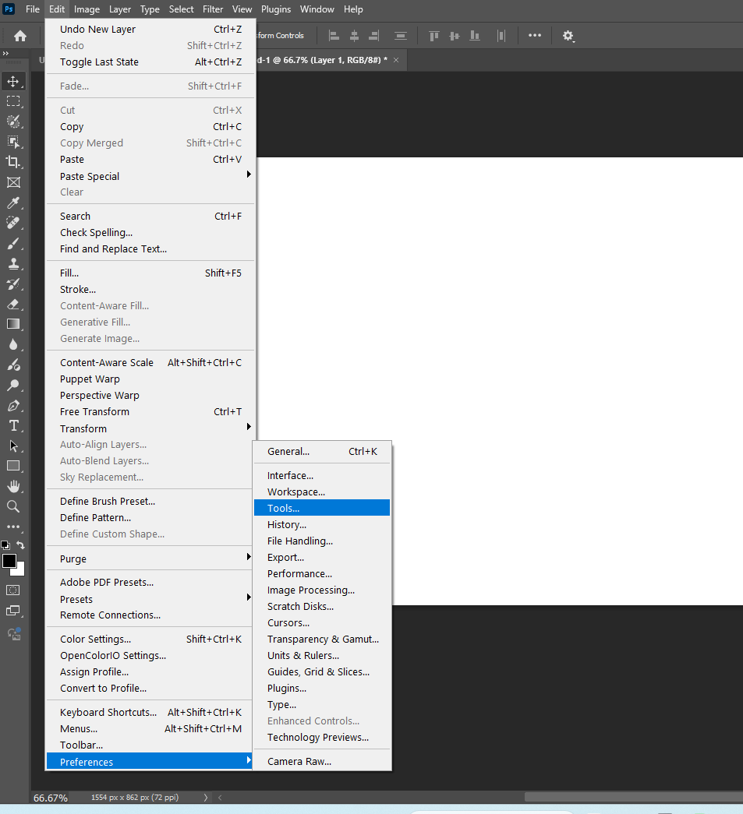
- Tick on the option ‘zoom with scroll wheel’, click on ‘OK’ to save the settings, then restart Photoshop.
