How to make my tablet show the same content as my Windows computer
When a drawing tablet display is connected to a Windows computer, you can change the display modes by pressing the Windows key and the P key at the same time. It applies to Windows laptops and PCs.
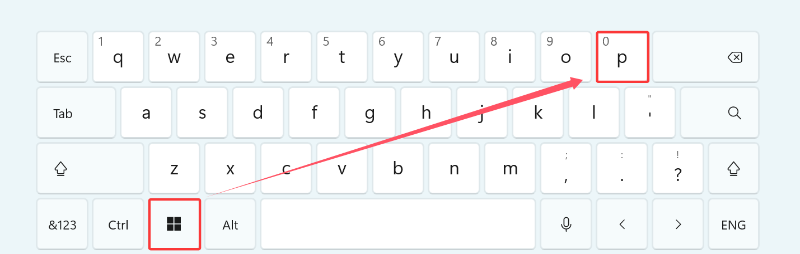
The small window pops up in the lower right side of the computer screen.
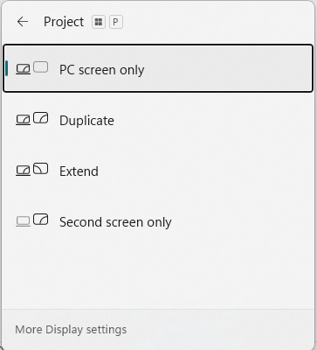
1. If you want to see the same content on both monitors, choose duplicate.
2. If you want to see different items and windows on the monitors, choose extend. When you are in extended display mode, you can move items between the two screens using the mouse.
3. When you choose one screen only, the other screen will show ‘no signal’ and go black.
4. More display settings can be accessed from settings>system>display.

