How to solve the No-Pen-pressue issue in OneNote2016?

For Windows users, if the pen pressure doesn’t work in OneNote2016, please check the following ways.

- Please open the UGEE driver> Pen Settings> check Windows Ink.
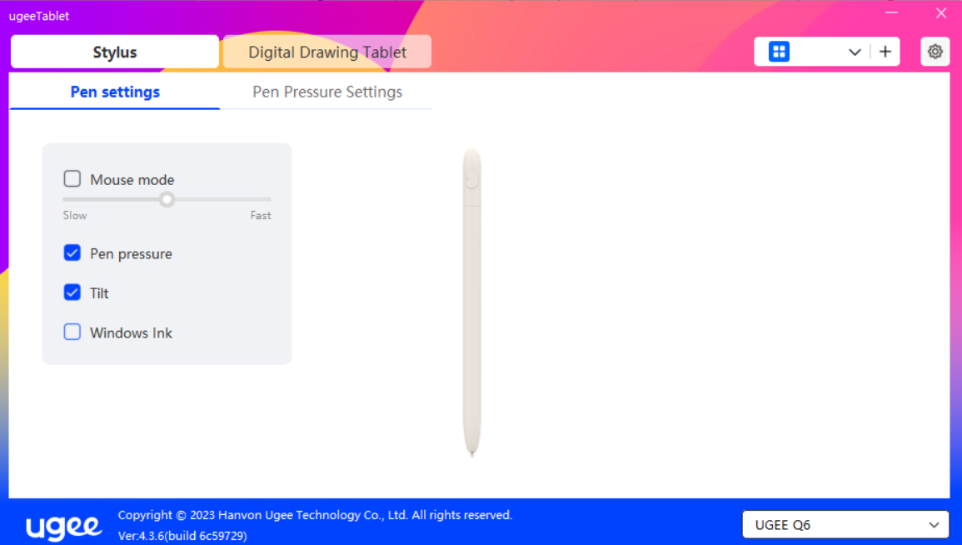

- Please open the OneNote app, click File> Option> Advanced>Use pen pressure sensitivity.
