How to solve the No-Pen-Pressue issue in CorelDRAW?

For Windows users, if the pen pressure doesn’t work in CorelDRAW, please check the following ways.

- Please open CorelDRAW -- Tools -- Options -- CorelDRAW.
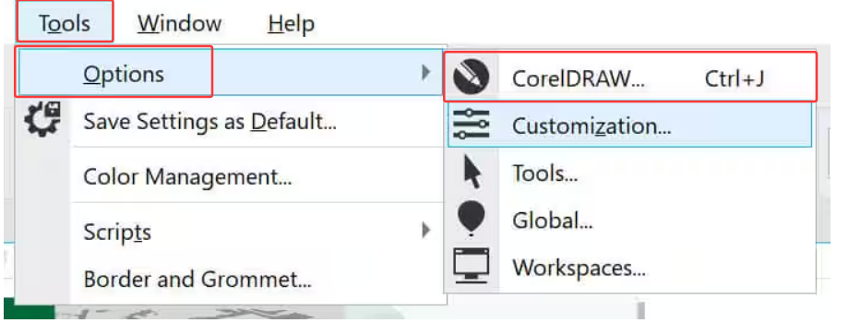

2. Please go to Pen Settings -- select WinTab.

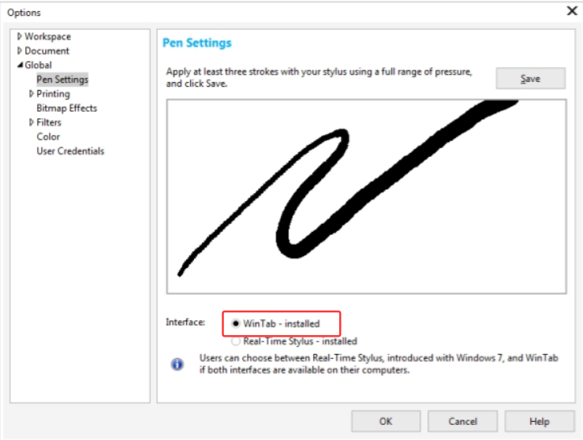

- Please open the UGEE driver -- Pen Settings -- Uncheck Windows Ink. Close and restart CorelDRAW.

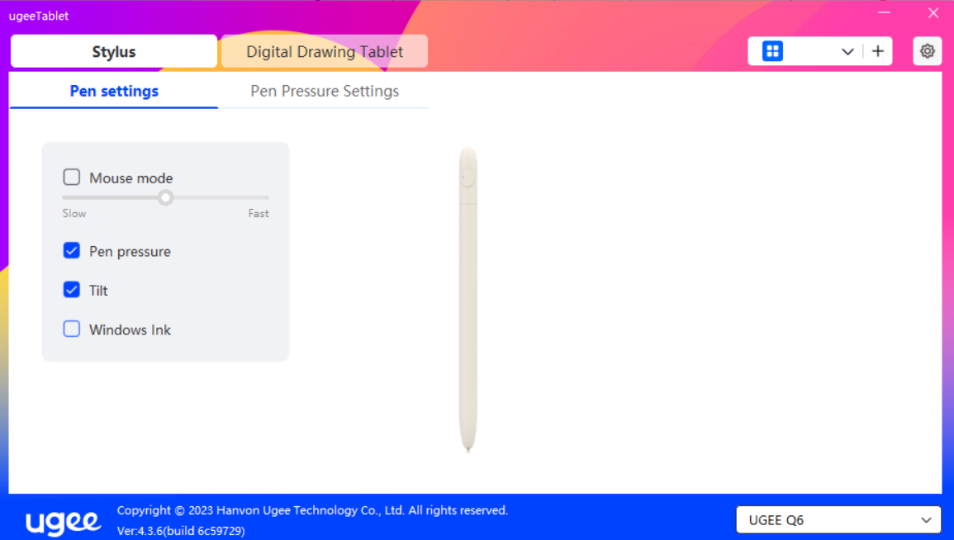

- Alternatively, check Windows Ink, select Real-Time Stylus, and restart CorelDRAW. These are two complementary modes; switch between them if there's no pressure sensitivity. Restart the software after each setting.

