How to solve the UGEE driver shows “please connect the device to PC first” issue?

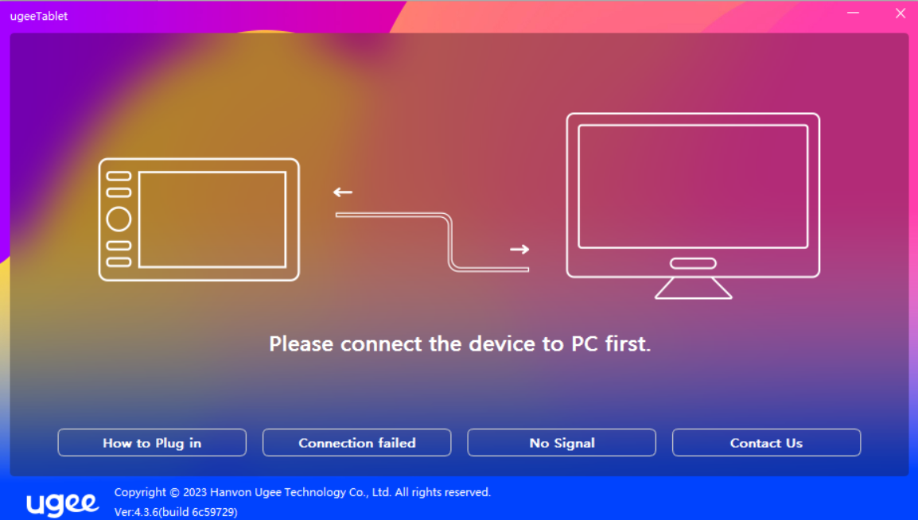

- When connecting the UGEE tablet to computer, the UGEE driver shows “please connect the device to PC first”, we will address the problem from two directions.
Situation1 If the pen can’t move the cursor, let’s check cable connection first. We provide a 3-in-1 cable.
The black USB cable is used to control pen and UGEE driver. Please directly connect it to computer’s USB port.
If the pen still doesn’t work, please uninstall UGEE driver, do not reinstall it, disconnect and reconnect the black USB cable to another USB port, see if the pen can work without a UGEE driver installed.

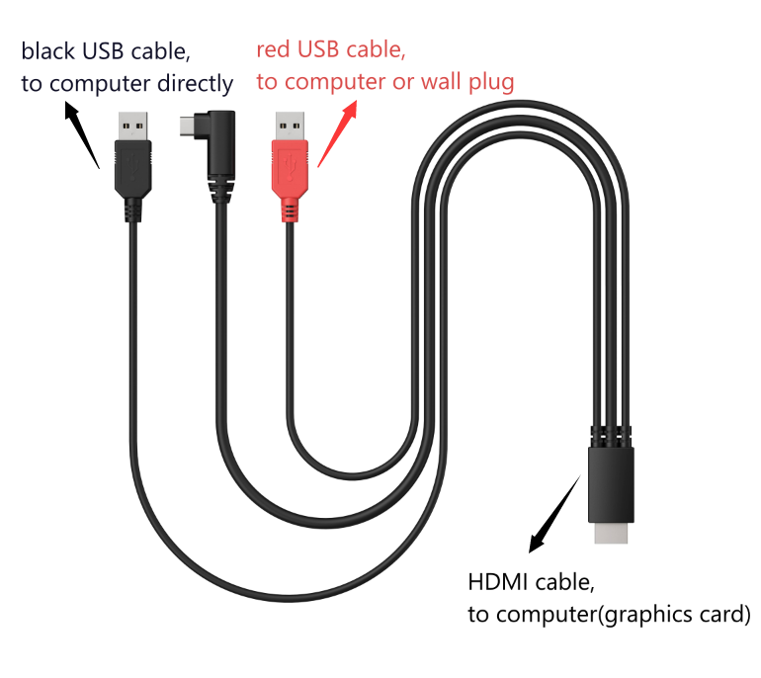

Situation2 If the pen can move the cursor, please check whether there is other brand drivers on your computer, uninstall them, last reinstall UGEE driver.

Last, if none of the solutions work, please contact our tech support team service@ugee.com

