How to solve the screen flickering issues in ASUS computer's duplicate mode?

- Please right-click on the desktop and click NVIDIA Control Panel.
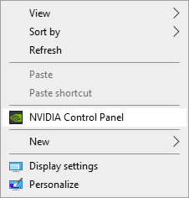

- Please click Configure Surround, PHysX. In this interface, click PHysX Settings, change the processor selection from Automatic to your computer's graphics card, and then restart your computer. You should then be able to use the cloning mode normally.

