How to solve the offset issue in CSP?

- Please open the UGEE driver, check the Windows ink.
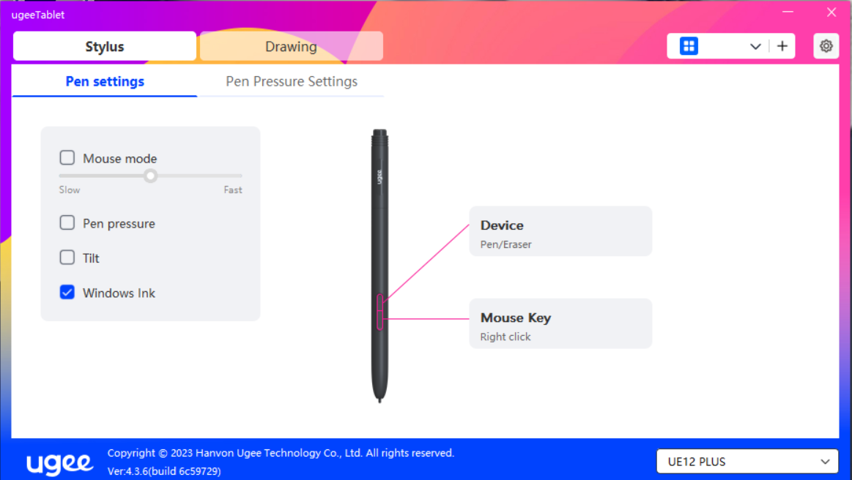

Please open CSP, click File> Preferences> Tablet> TabletPC> OK. Restart the CSP.
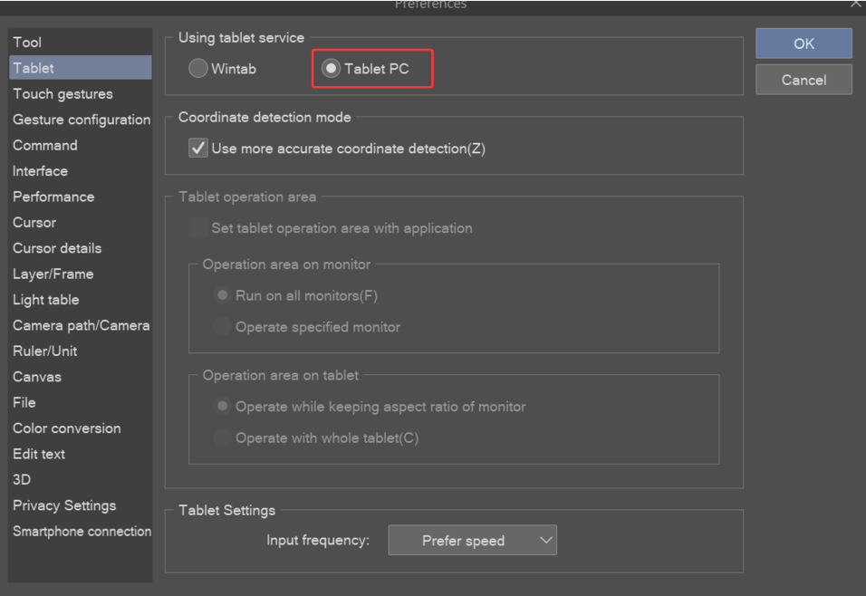

- If this way doesn’t help, please uncheck Windows ink, click File> Preferences> Tablet> Wintab> OK. Restart the CSP.
