How to solve the pen lag issue in Photoshop?

- Please check the menu bar at the top of Photoshop and adjust the Smoothing value to below 10.

- Please press Ctrl+Alt+I to check if the image size memory usage has increased.
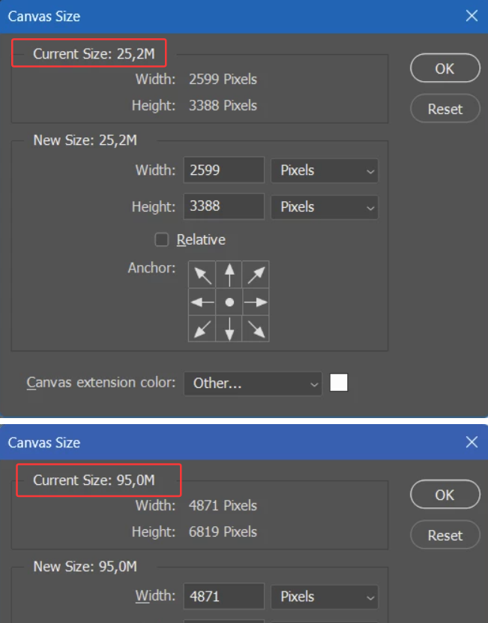

- Please go to Edit > Preferences > Performance and check if the performance percentage has increased.
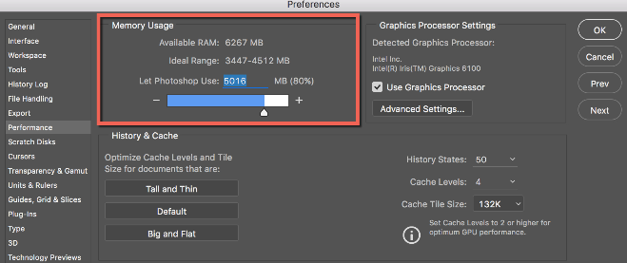

- If these above steps don’t help, it may be a problem with the drawing software. You may need to reinstall Photoshop and test again.

And please contact XPPEN tech support team: service@ugee.com

