How to solve the no pressure issue in SAI?

- Please open UGEE driver-Stylus-Pen Pressure Settings-Pressure Test, see if pen pressure works here.

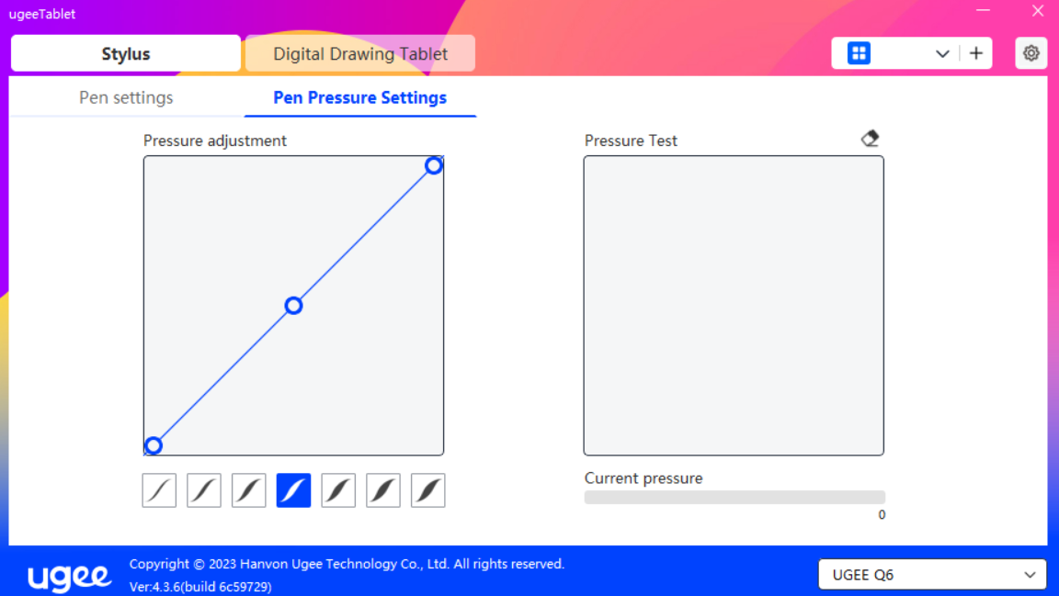

- If pen pressure doesn't work in SAI but does work in the pressure test box, we can adjust the following settings.

- Please open the UGEE driver, disable Windows Ink.
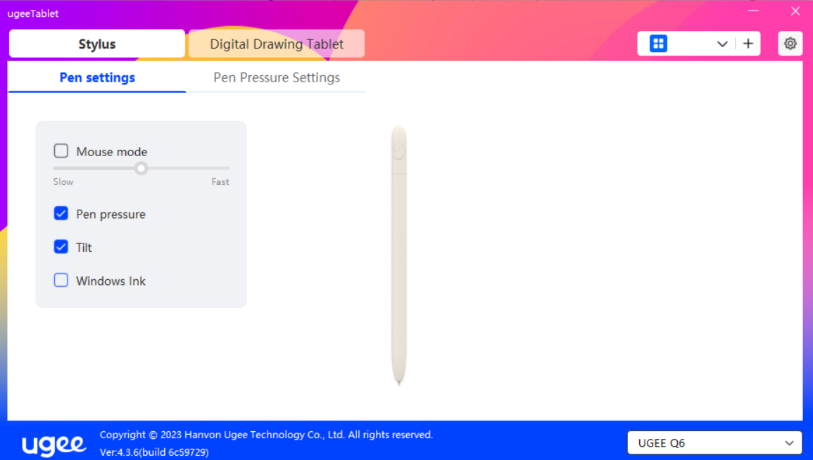

- Please open SAI, click Other> Options> pen tablet> Use WinTab API> OK. Restart SAI, test pen pressure again.

