How to solve the no pressure issue in CSP?

If the no-pen-pressure issue occurs only within CSP, please try the following methods.

- Please open UGEE driver-Stylus-Pen Pressure Settings-Pressure Test, see if pen pressure works here.

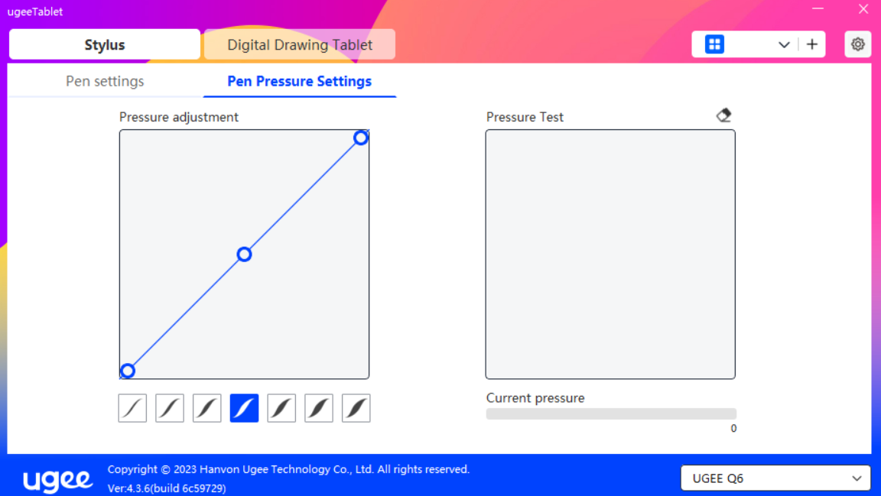

- If pen pressure doesn't work in CSP but does work in the pressure test box, we can adjust the following settings.

- Please open the UGEE driver, disable Windows Ink.
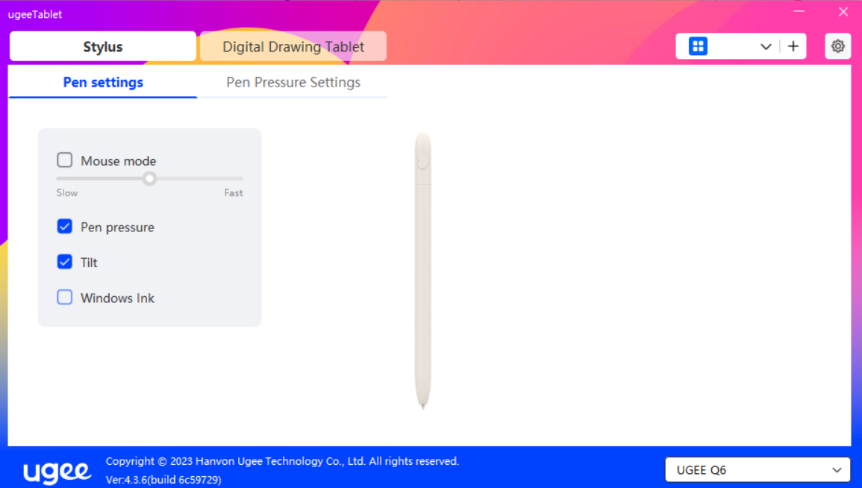

- Please open CSP, click File> Preferences> Tablet> Wintab> OK. Restart CSP, test pen pressure again.

