How to customize the scroll wheel rotation function for CSP?

- Please open UGEE driver> Drawing> Shortcut keys> Roller settings.
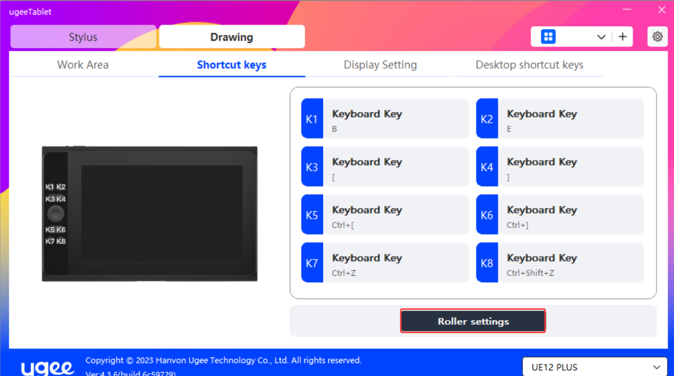

- Please click on the right and select Customize.
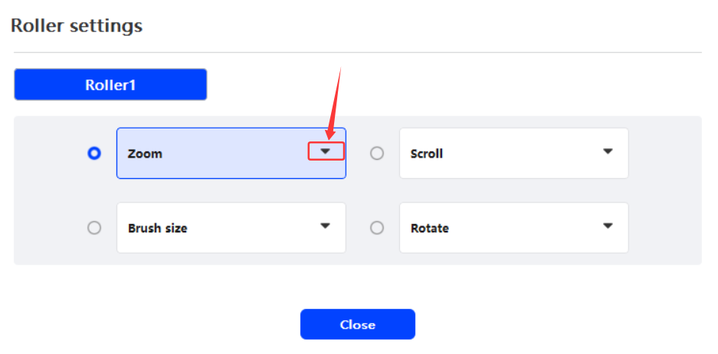

- For example, Ctrl++ and Ctrl+ -, last click OK.
