How to solve the problem of no sound when connecting a UGEE tablet to a Windows computer?

In most cases, the lack of sound when a tablet is connected to a computer is because the computer’s audio output device is set to HDMI. You can try the following methods. If the problem persists, please contact our technical support at service@ugee.com.

For example, if you use Windows 11 computer
- Find the small audio icon in the lower right corner of your computer.
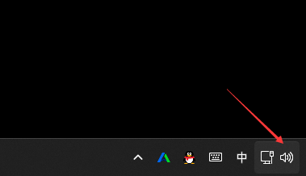
- Right-click and select "Open Sound Settings".
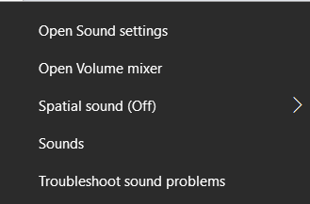
- Output--choose your output device，choose Speakers or Headphones.
